Web Scraping Project

* Go to the link: <https://store.steampowered.com/games/>
* You need to scrape the details of top 5 “New & Trending” Game details.
* You need to research how the webscraping is done and then start doing the project.

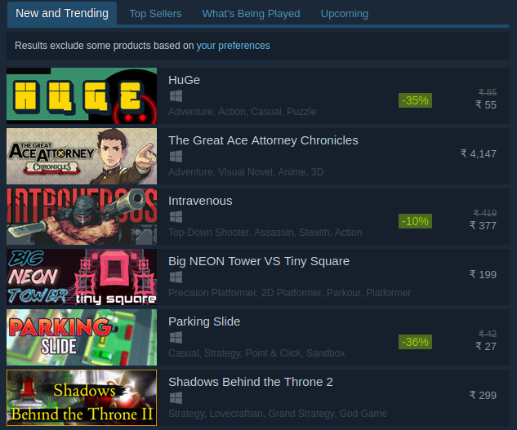

. For every game, find out the number of positive reviews and name of developer and publisher

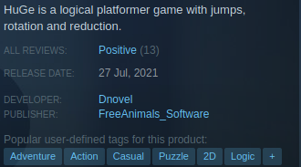

Find out the system requirements.

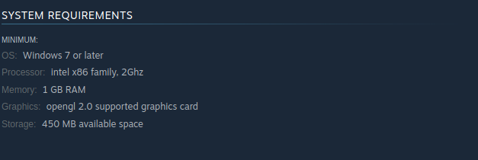

And 10 reviews for each game

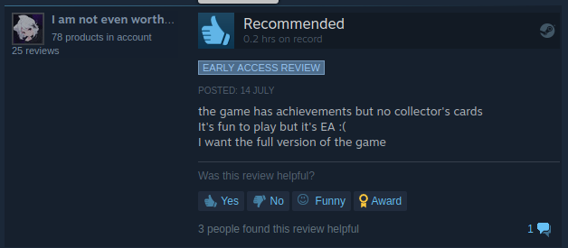

All The Very Best !!!

Regards

Aashish